Case Study
Retail: Store Sales Performance Analysis

Problem Statement
The regional sales leadership team wants to understand which regions, product categories, and discount strategies are actually driving profitable growth—not just generating revenue. While sales have increased over time, management suspects that aggressive discounting is eroding profit margins, particularly in certain product categories and sub-categories.
Without a clear understanding of profitability drivers, the company risks investing in products and regions that appear successful based on sales alone but contribute little—or even negatively—to overall business performance.
The objective of this analysis is to identify the most profitable products, regions, customer segments, and discount strategies while providing actionable recommendations to improve profitability and optimize future sales decisions.

Data Overview
- Source: Global Superstore Retail Dataset
- Records: ~10,000 Orders
- Tools Used: Excel, MySQL, Power BI
The dataset contains order information, shipping details, customer segments, geographic regions, product categories, sales, quantity, discounts, profit, profit margins, and time-based sales attributes.

Tool Stack
Excel (Data Cleaning) → MySQL (Business Analysis) → Power BI (Interactive Dashboard)

Business Questions
- Which region generates the highest sales and the highest profit?
- Which product categories deliver the strongest profit margins?
- Which sub-categories are generating losses despite high sales?
- How do discounts affect profitability?
- Are there seasonal sales trends throughout the year?
- Which customer segments contribute the highest revenue and profit?
- Which products should receive greater marketing investment?

Data Cleaning (Excel)
Performed data validation and quality checks before analysis.
Cleaning Steps
- Verified there were no duplicate order records.
- Checked for missing or blank values.
- Standardized text formatting across categorical fields.
- Converted Order Date and Ship Date into proper date format.
- Verified Sales, Profit, Quantity, and Discount values.
- Created Profit Margin (%) column.
- Extracted:
  - Order Year
  - Order Quarter
- Created Discount Bands:
  - 0%
  - 1–20%
  - 21–40%
  - Above 40%
Analysis (SQL)
Key Findings
1. Which region has the highest and lowest total sales?
Although West generated the highest total sales ($725457.93), and delivered the strongest profit margin (14.94%).
Other side South generated the lowest total sales demonstrating that revenue alone is not an accurate measure of business performance.
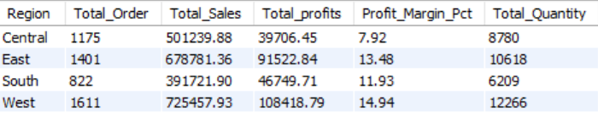

2. Which product categories are most profitable?
The Technology category recorded the highest average profit margin (17.40%) despite representing a smaller share of total orders of 1544.
Meanwhile, the Furniture category produced the weakest margins of 2.49%, suggesting pricing pressure and excessive discounting.
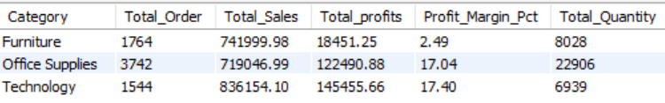

3. Are any product categories selling well but losing money (negative margin)?
The biggest profitability concern was Tables (Sub-Category of Furniture), which generated approximately $206965.68 in sales while producing -17725.59 in losses.
Increasing sales volume within this category actually reduces overall company profitability.
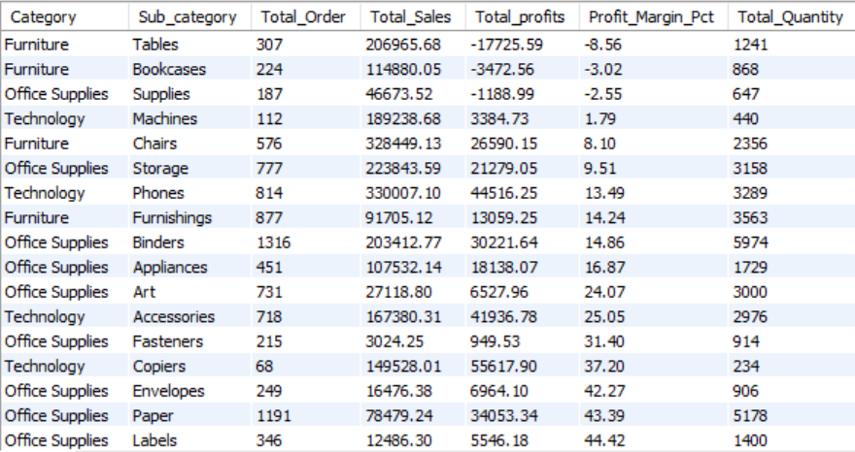
4. Does discounting improve business performance?
Higher discounts consistently reduced profitability.
Orders receiving discounts above 40% generated an average profit of $-106.71, indicating that excessive discounting destroys margin rather than stimulating profitable growth.
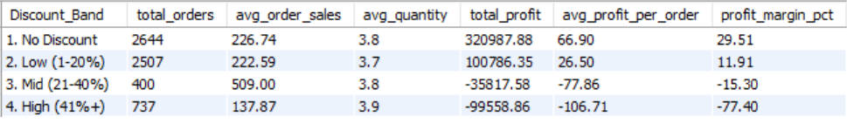

5. Is there seasonality in sales?
Sales consistently peak during Q4 (October–December) across all years.
Holiday demand represents the company's strongest revenue opportunity and requires proactive inventory planning.
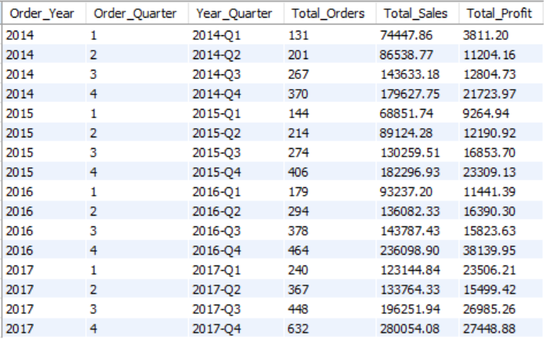
6. Which sub-categories receive the highest discounts?
Binders receives the highest average discount (37.2%) while simultaneously recording one of the weakest profit margin.
This suggests that discount strategies are compensating for weak pricing rather than creating sustainable demand.
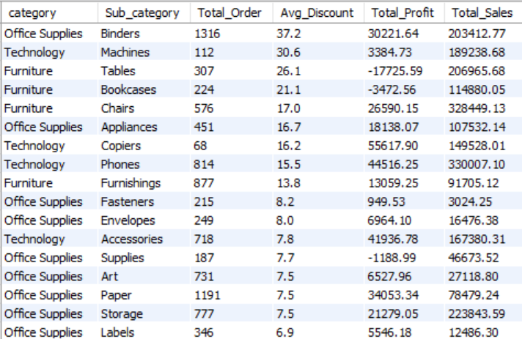
Other Findings
1. Customer Segment Performance
The Consumer customer segment contributes the highest overall sales and profit, making it the strongest target for future marketing campaigns and customer retention initiatives.
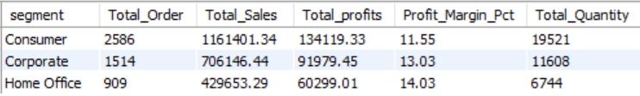

2. Customer Segment Performance
The Standard Class shipping Mode contributes the highest overall ($ 1358216.08) sales and
($ 164089.25) profit, making it the best shipping mode, other hand Same Day has lower sales and profits.
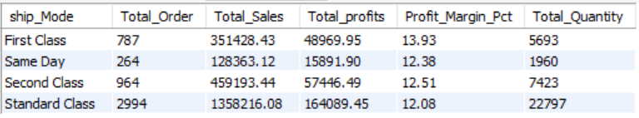

Dashboard (Power BI)
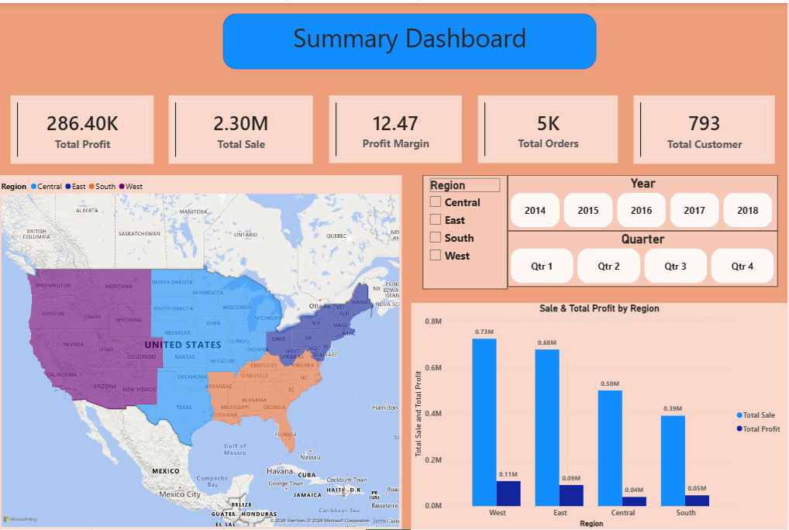
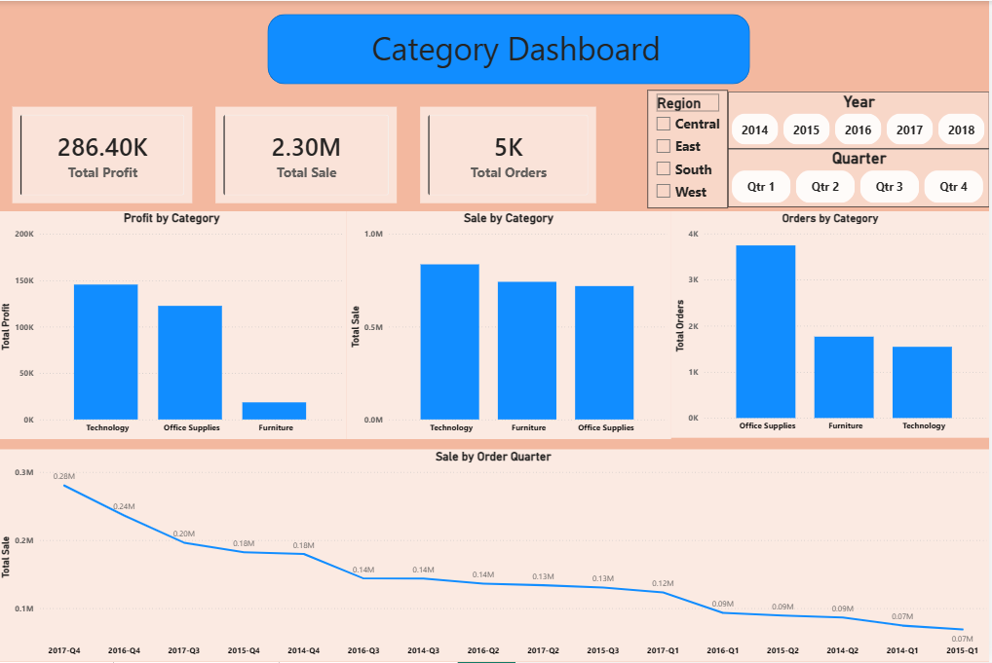
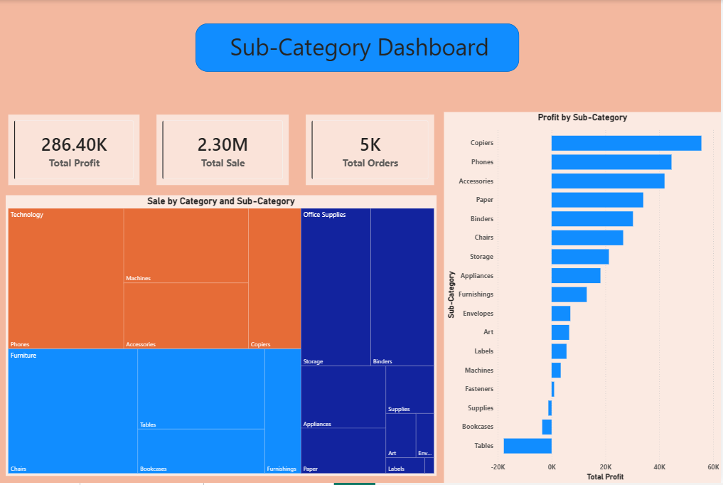
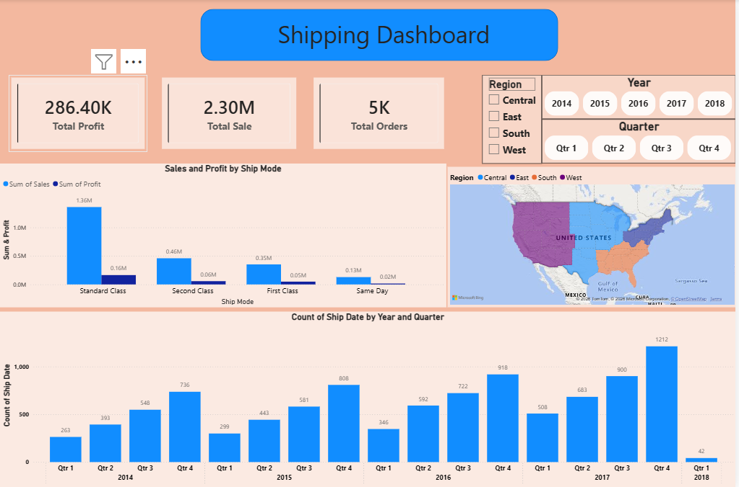
Recommendations
1. Reduce excessive discounting
Immediately review discount policies for loss-making sub-categories.
Products consistently sold at discounts above 40% should require management approval before promotion.

2. Reevaluate Furniture pricing
Furniture generates strong revenue but weak profitability.
Review supplier costs, pricing strategy, and discount policies to improve margins.

3. Invest in Technology products
Technology consistently delivers the strongest profit margins.
Increase inventory availability and marketing investment for high-margin products.

4. Prepare inventory ahead of Q4
Historical sales patterns show that Q4 generates the highest demand.
Forecast inventory requirements at least three months in advance to avoid stock shortages.

5. Introduce profit-based performance metrics
Evaluate business performance using both Sales and Profit Margin instead of revenue alone to prevent growth driven by unprofitable sales.

6. Monitor high-risk sub-categories
Create monthly profitability reports to identify products that generate high sales but consistently lose money.

7. Implement discount governance
Require approval for discounts above 20%, supported by a projected margin impact analysis before implementation.

